Docker and Kind are recommended to be downloaded locally to follow the contents during the workshop. It can be installed in the host machine, inside virtual-box image (para-virtualization might have to be enabled) or in the WSL.

Workshop author would be using Windows OS as the main host with Ubuntu WSL installed (and all the necessary tools inside WSL). Attendees are open to install the tools in WSL/VM/Windows or Linux host machine as long as there is no error while creating a test cluster or running a local docker image.

# Installing Docker

On [MacOS](https://docs.docker.com/desktop/install/mac-install/) and [Windows](https://docs.docker.com/desktop/install/windows-install/): Download Docker Desktop

On Linux

# Remove any conflicting packages first

*for pkg in docker.io docker-doc docker-compose podman-docker containerd runc; do sudo apt-get remove $pkg; done*

# Setup apt repositories for installing docker

*sudo apt-get update  
sudo apt-get install ca-certificates curl gnupg  
sudo install -m 0755 -d /etc/apt/keyrings  
curl -fsSL https://download.docker.com/linux/ubuntu/gpg | sudo gpg --dearmor -o /etc/apt/keyrings/docker.gpg  
sudo chmod a+r /etc/apt/keyrings/docker.gpg*

*echo "deb [arch="$(dpkg --print-architecture)" signed-by=/etc/apt/keyrings/docker.gpg] https://download.docker.com/linux/ubuntu \  
"$(. /etc/os-release && echo "$VERSION_CODENAME")" stable" | \  
sudo tee /etc/apt/sources.list.d/docker.list > /dev/null  
sudo apt-get update*

# Install Docker

*sudo apt-get install docker-ce docker-ce-cli containerd.io docker-buildx-plugin docker-compose-plugin*

# Post-installation steps

*sudo groupadd docker   
sudo usermod -aG docker $USER  
newgrp docker*

If everything has been installed and configured correctly, you should be able to pull a image and run the following (irrespective of the OS):

*docker run hello-world  
docker ps -a*

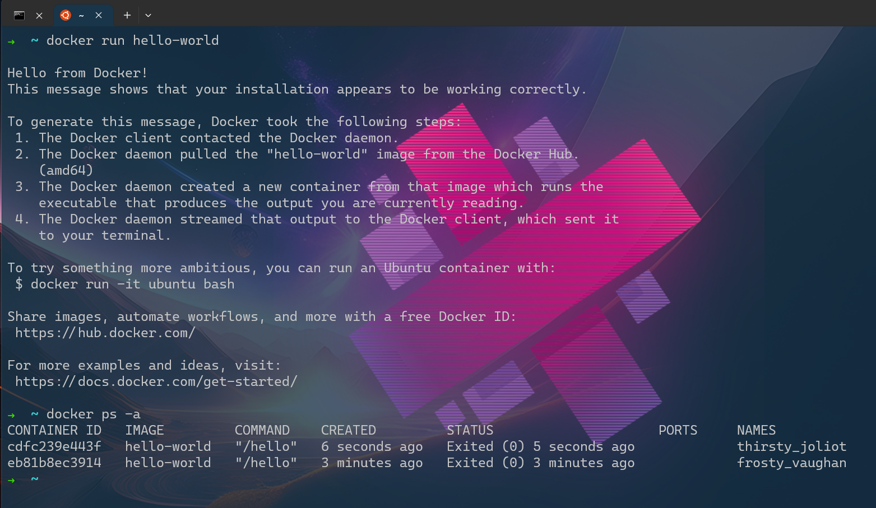

# Installing Kind

On macOS (homebrew has to be [installed](https://docs.brew.sh/Installation))

*brew install kind*

On Windows (using Powershell administrator)

*curl.exe -Lo kind-windows-amd64.exe* [*https://kind.sigs.k8s.io/dl/v0.20.0/kind-windows-amd64*](https://kind.sigs.k8s.io/dl/v0.20.0/kind-windows-amd64)

*Move-Item .\kind-windows-amd64.exe C:\<some-dir-in-your-PATH>\kind.exe*

On Linux

# Instructions for AMD64 / x86_64 (if you have an ARM64 device, download kind-linux-arm64 instead of kind-linux-amd64)

*[ $(uname -m) = x86_64 ] && curl -Lo ./kind* [*https://kind.sigs.k8s.io/dl/v0.20.0/kind-linux-amd64*](https://kind.sigs.k8s.io/dl/v0.20.0/kind-linux-amd64)

*chmod +x ./kind  
sudo mv ./kind /usr/local/bin/kind*

If none of the methods work, more ways of installing documented in the [official page.](https://kind.sigs.k8s.io/docs/user/quick-start/#installation)

# Installing kubectl

<https://kubernetes.io/docs/tasks/tools/>